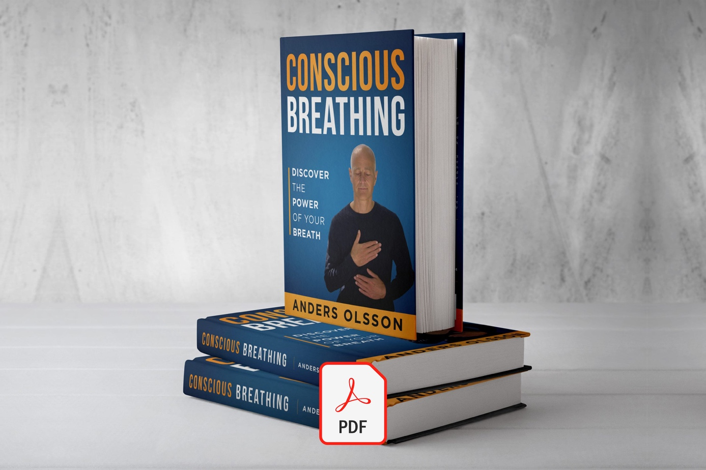

Join Our Community

10 Powerful Reasons to Breathe Through Your Nose

10 Powerful Reasons to Breathe Through Your Nose
30 juni 2025
You do it 20,000 times a day—and how you breathe makes all the difference.
While mouth breathing can disrupt sleep, drain your energy, and leave you feeling stressed, nasal breathing is essential for health, vitality, and restful sleep. When we breathe through the nose, we’re doing more than just taking in air—we're engaging a finely tuned system designed to optimize every breath.
The part of the nose you can see and touch is just the tip of the iceberg. Hidden within the skull, the nasal cavity takes up space roughly the size of a billiard ball—revealing just how complex and essential this overlooked organ really is.
Here are 10 science-backed reasons to make nasal breathing your default—day and night.

1. The Nose Is a Natural Filter
Your nose filters, warms, and humidifies the air you breathe. It traps dust, allergens, and pathogens that would otherwise irritate or inflame your lungs. It functions both as a self-cleaning bacterial filter and an effective heat exchanger, preparing the air for the airways and lungs.
Mouth breathing bypasses all of this, leaving your airways dry, inflamed, swollen, and more prone to infection.
Read more: Mouth breathing causes colds

2. Nitric Oxide: Nature’s Antiviral Molecule
When you breathe through your nose, nitric oxide (NO) is released from your sinuses and carried into your lungs. This powerful molecule has antiviral, antibacterial, and antifungal effects.
It also acts as a vasodilator—helping to relax blood vessels, improve circulation, and enhance oxygen delivery.
Read more: CO₂ and Nitric Oxide: Their Role in Blood Flow and Sexual Dysfunction

3. Better Oxygen Delivery to Your Cells
Contrary to popular belief, more air does not mean more oxygen. At rest, we use only about 25% of the oxygen we inhale—the rest is exhaled. Breathing more than the body needs, especially through the mouth, does not increase oxygen uptake. In fact, it can do the opposite.
Nasal breathing helps maintain healthy carbon dioxide (CO₂) levels, which are essential for releasing oxygen from the blood into the tissues—a principle known as the Bohr effect. Without enough CO₂, hemoglobin holds on to oxygen more tightly, making it harder for your cells to access what they need.
Mouth breathing often leads to chronic over-breathing, which lowers CO₂ levels and reduces oxygen delivery. This can trigger symptoms like tension, breathlessness, dizziness, and anxiety—even when oxygen levels in the blood appear normal.
Too much oxygen, especially when it goes unused, can also be toxic. Excess oxygen increases the formation of free radicals, unstable molecules that cause oxidative stress and inflammation. Over time, this contributes to cellular damage, premature aging, and increased risk of chronic disease.
In short, nasal breathing ensures oxygen is used efficiently, not excessively—protecting your cells, reducing inflammation, and keeping your energy steady and balanced.
Read more: Oxygen restriction for a longer and healthier life

4. Deeper, More Restorative Sleep
Nasal breathing encourages slower, more rhythmic breathing patterns, which ensures a steady supply of oxygen to the brain, signals safety and helps calm the nervous system. This promotes deeper, more restorative sleep and reduces nighttime awakenings.
Humans are the only animals that sleep with their mouths open. Mouth breathing is often linked to snoring, dry mouth, restless sleep, and even increased nighttime urination. Mouth breathing at rest automatically leads to mild hyperventilation, which activates the stress response—something obviously not desired while asleep. Over time, poor breathing at night can contribute to daytime fatigue, irritability, and reduced mental clarity.
One of sleep’s most vital functions is to clear waste and toxins from the brain, a process carried out by the glymphatic system, which is most active during deep sleep. If sleep is shallow or disrupted—as often happens with mouth breathing—this cleansing process is impaired. Over time, this may contribute to the accumulation of toxins in the brain and increase the risk of neurodegenerative conditions such as Alzheimer’s and Parkinson’s disease.
Read more: Breathe Better - Get Quality Sleep

5. Improved Focus and Nervous System Balance
The brain is the body’s main consumer of oxygen—and the organ most affected by impaired breathing habits.
Nasal breathing naturally activates the diaphragm and slows the breathing rate, which helps raise carbon dioxide (CO₂) levels in the body. Since CO₂ is the primary regulator of blood flow to the brain, maintaining healthy levels supports optimal oxygen delivery and neural function.
As a result, nasal breathing helps shift the body into a parasympathetic state—the rest, repair, recover, and digest mode. This promotes mental clarity, emotional balance, and reduced stress.
In contrast, mouth breathing—especially when fast or shallow—can activate the stress response and increase tension, anxiety, and mental fatigue.
Read more: Calming down a stressed brain

6. Enhanced Athletic Performance
Efficient breathing is key to endurance and recovery. Nasal breathing regulates CO₂, increases nitric oxide, improves oxygen utilization, and reduces the buildup of lactic acid. It also helps athletes maintain a calm focus, lower their heart rate, and recover faster after exercise.
Nasal breathing:
- Encourages slower breathing into the lower part of the lungs, where blood flow is greatest and gas exchange is most efficient.
- Trains the diaphragm and supports core and postural stability—especially important in high-intensity sports.
- Activates the parasympathetic nervous system more effectively during recovery, allowing the body to rebound faster between workouts or events.
Read more: Conscious Breathing for Optimum Sports Performance

7. Facial Development and Airway Health
In children, chronic mouth breathing can impair jaw and facial development, leading to a high palate, receding chin, crowded teeth, and narrowed airways. These structural changes often contribute to snoring, sleep-disordered breathing, and poor posture.
Nasal breathing, on the other hand, encourages healthy growth by supporting proper tongue posture and facial muscle function. When the tongue rests against the palate and the mouth stays closed, the upper jaw (maxilla) grows forward and outward—helping to shape a wider face, stronger chin, and more open nasal passages.
Since up to 90% of facial development is complete by early adolescence, the sooner nasal breathing is restored, the better the outcomes for proper jaw development, healthy posture, proper bite, and lifelong airway health.
Read more: Mouth breathing negatively affects children's smile, teeth, face, and airways
Download eBook: Shut Your Mouth and Save Your Life

8. Brain Stimulation
The nose is unique among the senses—as the airflow travels directly into the brain without a filter. Nasal airflow stimulates the olfactory nerves, which connect directly to the amygdala (our emotional center) and the hippocampus (the memory and learning center). This means that how we breathe affects not just our body, but our mood, memory, and mental clarity.
Nasal breathing helps regulate activity in these brain regions and promotes calm, focused states. In contrast, mouth breathing bypasses this direct brain stimulation and is often associated with higher stress and reduced cognitive performance.
Interestingly, the amygdala also contains special sensors, chemoreceptors, that detect carbon dioxide levels—just like those sensors that regulate our breathing. When CO₂ tolerance is low (as it often is with mouth breathing), the amygdala becomes more reactive, which can increase fear, anxiety, and emotional instability.
On the other hand, nasal breathing improves CO₂ tolerance, helping calm the fear response, and enhances learning and memory by stimulating the hippocampus. In short, breathing through your nose doesn’t just clear your head—it strengthens it.

9. Boosts Intimacy and Sex Life
Nitric oxide produced through nasal breathing doesn’t just help your lungs—it enhances blood flow throughout the entire body, including the genitals. For both men and women, good circulation is essential to arousal, pleasure, and satisfaction.
In fact, nitric oxide is the basis of many erectile dysfunction treatments. For example, Viagra enhances the production of nitric oxide, and your body produces it naturally—when you breathe through your nose.
Read more: The Nose Knows: How Nasal Breathing Enhances Sexual Vitality

10. Greater Longevity and Resilience
Mouth breathing has been linked to a higher risk of chronic conditions like hypertension, fatigue, inflammation, and sleep-disordered breathing. Over time, these issues can erode both quality and length of life.
Nasal breathing, by contrast, supports a balanced internal environment. It supports better oxygen-carbon dioxide regulation, reduces oxidative stress, and strengthens the body's ability to recover from stress, illness, and injury—all of which contribute to long-term vitality and disease resistance.
Read more: Breathe Less - Live Longer

Final Thoughts
Switching from mouth to nasal breathing may seem like a small change, but it unlocks profound benefits for your health, sleep, focus, mood, vitality, and quality of life.
Whether you're aiming for better sleep, clearer focus, move better, experience deeper intimacy—or simply want to feel more at home in your body—the nose knows.
Explore: The 5 best tips for restoring nasal breathing

