How The 4-7-8 Breathing Technique Can Help Relieve Stress and Anxiety

By

[Arlin Cuncic, MA](https://www.verywellmind.com/arlin-cuncic-3024162)

Updated on December 12, 2023

 Medically reviewed by

[Steven Gans, MD](https://www.verywellmind.com/steven-gans-md-4779222)

Formulärets överkant

Print

Formulärets nederkant

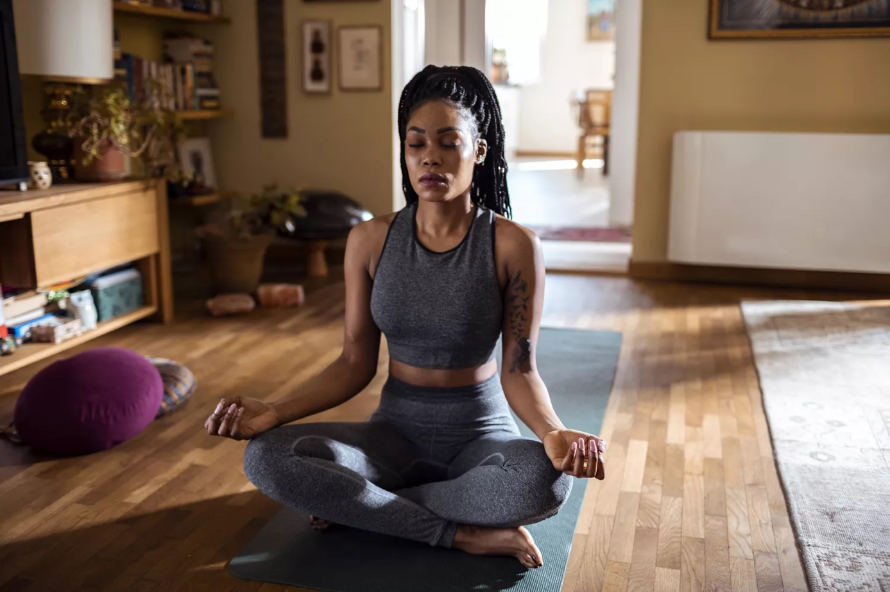

Marko Geber / Getty Images

Table of Contents

* [How It Works](https://www.verywellmind.com/what-is-4-7-8-breathing-5204438#toc-how-4-7-8-breathing-works)
* [How to Practice](https://www.verywellmind.com/what-is-4-7-8-breathing-5204438#toc-how-to-practice-4-7-8-breathing)
* [When to Use This Technique](https://www.verywellmind.com/what-is-4-7-8-breathing-5204438#toc-when-to-use-this-technique)
* [Benefits](https://www.verywellmind.com/what-is-4-7-8-breathing-5204438#toc-benefits)
* [Tips for Practicing](https://www.verywellmind.com/what-is-4-7-8-breathing-5204438#toc-tips-for-practicing-this-technique)
* [Potential Pitfalls](https://www.verywellmind.com/what-is-4-7-8-breathing-5204438#toc-potential-pitfalls)

Trending Videos

[MUSIC PLAYING]

0 seconds of 36 secondsVolume 0%

4-7-8 breathing is a technique for deep relaxation conceived by Harvard-trained medical doctor and founder of the Arizona Center for Integrative Medicine [Dr. Andrew Weil](https://www.drweil.com/videos-features/videos/breathing-exercises-4-7-8-breath/).

Many people use this counting technique to [manage stress](https://www.verywellmind.com/stress-and-health-3145086) and anxiety through controlled breathing. Specifically, it involves inhaling for the count of four, holding your breath for the count of seven, and exhaling for the count of eight.

In May of 2015,1 Dr. Weil popularized this [breathing technique](https://www.verywellmind.com/abdominal-breathing-2584115) to help people manage stress and anxiety. The 4-7-8 breathing technique is based on the [pranayama breathing exercise](https://www.verywellmind.com/an-overview-of-coherent-breathing-4178943)that is practiced during [yoga for relaxation](https://www.verywellmind.com/yoga-can-reduce-work-related-stress-study-shows-5193478).

How 4-7-8 Breathing Works

Are you someone who needs to understand "why" something works before you'll give it a try? If so, here's the rationale behind the technique.2

* Using the 4-7-8 breathing technique activates your parasympathetic nervous system, which is responsible for relaxation.
* When you activate this system, your body suppresses the opposite system (sympathetic nervous system) that is responsible for the stress response (e.g., the [fight or flight reaction](https://www.verywellmind.com/what-is-the-fight-or-flight-response-2795194)).
* While you can use this technique to calm anxiety in the moment, Dr. Weil emphasizes that it is best used as a daily preventative practice.
* Using this breathing practice regularly helps to make the voluntary practice involuntary.
* The speed with which you do the breathing practice does not matter. Instead, it is important to maintain the ratio of 4-7-83 so that the exhale is longer than the inhale, according to Dr. Weil.

[The Benefits of Meditation for Stress Management](https://www.verywellmind.com/meditation-4157199)

How to Practice 4-7-8 Breathing

If you want to start this breathing practice but aren't sure how to get started, it's helpful to know that it is one of the most straightforward techniques you can learn.

There are some specific techniques involved in the practice of this type of breathing, so it's important to pay attention to the details.

Here is a list of steps on how to practice this breathing technique. You can also [watch Dr. Weil describe the procedure himself](https://www.youtube.com/watch?v=p8fjYPC-k2k&t=4s).

**Step 1**. Find a comfortable spot where you can sit quietly without being disturbed.

**Step 2**. Gently place your tongue so that it is pressing against the back of your top teeth.

**Step 3**. Exhale all of the air around your tongue through your open mouth.

**Step 4**. Close your mouth and then inhale for a count of 4 through your nose.

**Step 5**. Now, count to seven while you hold your breath.

**Step 6**. Finally, exhale through your mouth for a count of eight. Make an audible "whoosh" sound as you exhale. Once you have exhaled fully, it should feel as though all of the air has left.

**Step 7**. Do a total of four cycles, repeating the previous steps.

The more often that you can practice this technique, the more quickly you will notice results. Ideally, according to Dr. Weil, you should practice at least twice a day though you can do it more often if you are so inclined.

Within just a few short minutes, this breathing technique will help activate your parasympathetic response and slow down your [heart rate](https://www.verywellmind.com/stress-doubles-risk-of-second-heart-attack-in-younger-folks-5184595) while lowering blood pressure. You can use 4-7-8 breathing in many different instances, including when feeling stressed or anxious before bedtime, which is another great reason why practicing at night. Once you become comfortable with doing four cycles, you can increase to a maximum of eight cycles.

When to Use This Technique

The primary use of this breathing technique is to lower your stress response over time.4 This means practicing daily to notice an improvement in the long term. However, 4-7-8 breathing can also help keep you calm in a variety of stressful situations. You can use it to alleviate symptoms associated with stress, anxiety, and [panic attacks](https://www.verywellmind.com/shortness-of-breath-2584249). Below are some specific situations in which you might find this 4-7-8 breathing helpful.

* At work, when experiencing stress
* While driving in traffic or commuting to work each day
* Before giving a speech or presentation at school or work
* During an exam period at university/college
* At night when trying to fall asleep
* First thing in the morning, when you wake up
* When experiencing pre-class nerves in university/college
* If you are feeling overwhelmed, anxious, or stressed
* When practicing other relaxation exercises (e.g., progressive muscle relaxation, guided imagery)
* When doing yoga or tai chi
* When practicing mindfulness meditation

[Holotropic Breathwork Benefits and Risks](https://www.verywellmind.com/holotropic-breathwork-4175431)

Benefits

While there is a lack of research on the 4-7-8 breathing technique specifically, other research shows the benefits of other similar deep breathing exercises.

* **Reduced depression and anxiety**.In one study, participants with COPD who practiced controlled breathing techniques experienced reduced symptoms of [depression](https://www.verywellmind.com/what-is-moderate-depression-5072794) and anxiety.5
* **Improved sleep quality**. In another study, people with insomnia experienced improved sleep quality after practicing slow, paced breathing exercises for 20 minutes before sleeping.6
* **Reduced stress levels**.According to the American Institute of Stress, slow abdominal breathing can help reduce stress levels by slowing down your heart rate and lowering blood pressure.7 Additionally, it helps relax tense muscles and increase oxygen intake, both of which aid relaxation.
* **Improved motor memory**. Furthermore, another study showed improved motor memory in a group of 16 participants who practiced a 30-minute session of deep breathing.8
* **Improved pain processing**.Finally, there is evidence that slow breathing can influence autonomic function and pain processing/perception.9

[9 Breathing Exercises to Relieve Anxiety](https://www.verywellmind.com/abdominal-breathing-2584115)

Tips for Practicing This Technique

It might feel strange at first to practice breathing this way. Try to push through those initial feelings of discomfort. Practice this technique as often as you need to until it becomes automatic for you. Here are a few tips that might be helpful:

* Find a quiet place where others won't bother you while performing the exercise.
* Make sure you are seated comfortably with good posture while practicing this exercise (don't lie down).
* Try not to focus on other thoughts during practice. Instead, try and keep all attention focused on your breath.

[9 Breathing Exercises to Relieve Anxiety](https://www.verywellmind.com/abdominal-breathing-2584115)

Potential Pitfalls

While there are many ways to practice 4-7-8 breathing, you should consider whether a different approach works for you better than the one described here.

The biggest pitfall of a breathing technique like 4-7-8 breathing is that people forget to practice. It takes about 30 days to form a new habit, so be patient with yourself until this becomes part of your day-to-day routine.

Keep in Mind

The 4-7-8 breathing technique described in this article can potentially help reduce stress, anxiety, and depression.

What's more, it may have other benefits like improved concentration and better sleep quality. If you're looking for something easy to do that will make a difference in your life then this simple technique may be all you need.

It is important to remember that this breathing technique should not be used as a replacement for seeking help from professionals when necessary. It can also be helpful to learn other relaxation techniques such as [progressive muscle relaxation](https://www.verywellmind.com/how-do-i-practice-progressive-muscle-relaxation-3024400) and meditation.

9 Sources

**By [Arlin Cuncic, MA](https://www.verywellmind.com/arlin-cuncic-3024162)**  
Arlin Cuncic, MA, is the author of "Therapy in Focus: What to Expect from CBT for Social Anxiety Disorder" and "7 Weeks to Reduce Anxiety." She has a Master's degree in psychology.

[See Our Editorial Process](https://www.verywellmind.com/our-editorial-process-4778006)

[Meet Our Review Board](https://www.verywellmind.com/review-board-4796494)

Share Feedback

Related Articles

[[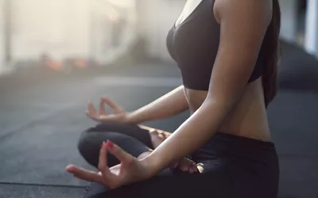](https://www.verywellmind.com/an-overview-of-coherent-breathing-4178943)](https://www.verywellmind.com/an-overview-of-coherent-breathing-4178943)

[An Overview of Coherent Breathing](https://www.verywellmind.com/an-overview-of-coherent-breathing-4178943)

[[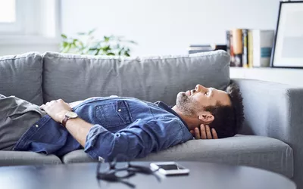](https://www.verywellmind.com/breathing-exercises-for-sleep-4589393)](https://www.verywellmind.com/breathing-exercises-for-sleep-4589393)

[7 Breathing Exercises for Better Sleep](https://www.verywellmind.com/breathing-exercises-for-sleep-4589393)

[9 Breathing Exercises to Relieve Anxiety](https://www.verywellmind.com/abdominal-breathing-2584115)

[[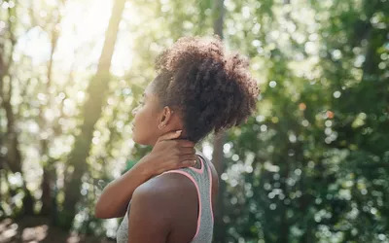](https://www.verywellmind.com/reduce-tension-with-progressive-muscle-relaxation-3144608)](https://www.verywellmind.com/reduce-tension-with-progressive-muscle-relaxation-3144608)

[Release Body Tension With Progressive Muscle Relaxation](https://www.verywellmind.com/reduce-tension-with-progressive-muscle-relaxation-3144608)

[[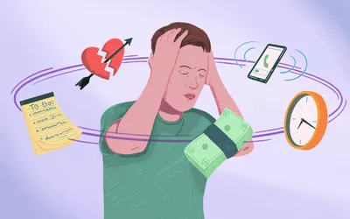](https://www.verywellmind.com/things-i-tell-my-patients-when-they-re-feeling-overwhelmed-7565447)](https://www.verywellmind.com/things-i-tell-my-patients-when-they-re-feeling-overwhelmed-7565447)

[As a Therapist, Here Are 5 Things I Tell My Patients When They’re Feeling Overwhelmed](https://www.verywellmind.com/things-i-tell-my-patients-when-they-re-feeling-overwhelmed-7565447)

[[](https://www.verywellmind.com/how-to-cope-with-civil-unrest-8364813)](https://www.verywellmind.com/how-to-cope-with-civil-unrest-8364813)

[As a Therapist, Here Are 4 Ways to Cope in Times of Civil Unrest](https://www.verywellmind.com/how-to-cope-with-civil-unrest-8364813)